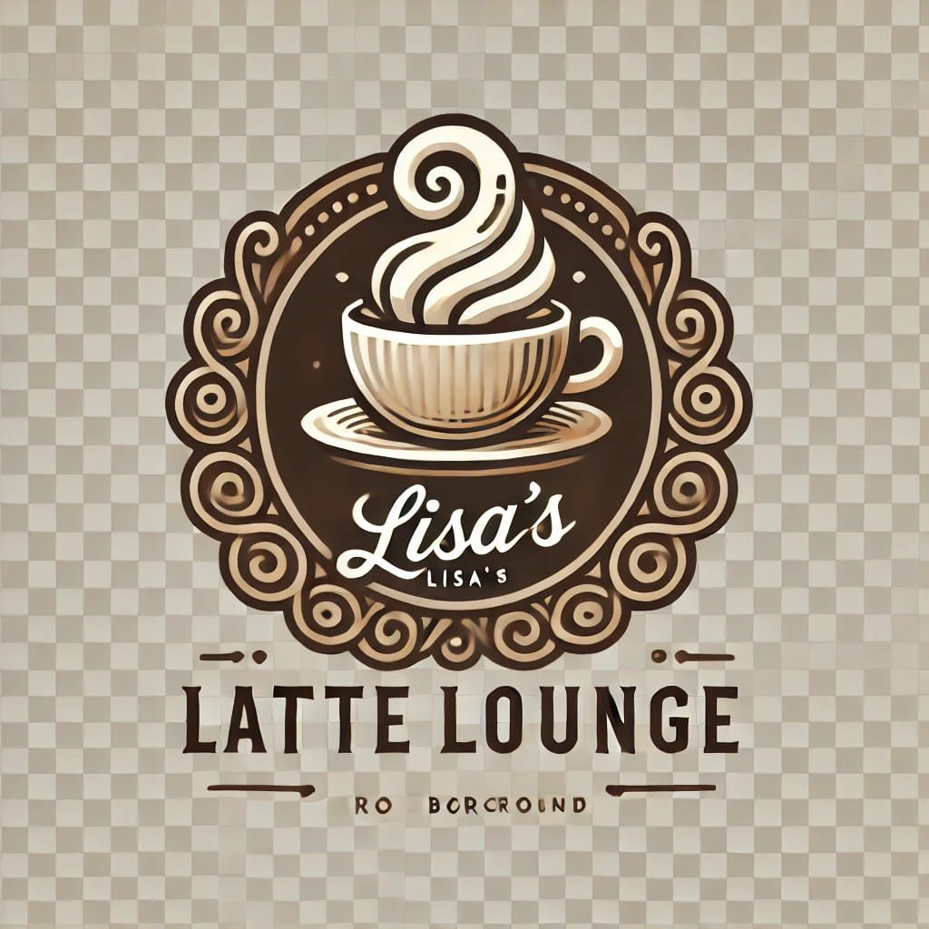  **THE ART OF COFFEE**

**ENTREPRENEURSHIP**

***JIHANA AKTER LISA***

***BATCH: 20***

***DATE: 04-10-24***

**Index:**

**1.Executive Summary:** 2

**2.Products and Services:** 2

**2.1. Products:** 2

2.1.1. Coffee Beverages: 2

2.1.2. Specialty Drinks 2

2.1.3 Non-Coffee Beverages: 2

2.1.3. Food Menu: 2

**2.2.** **Services:** 3

**2.3.** **Hyperlink:** 3

**2.4.** **SmartArt:** 3

**3.Business Plan:** 4

**4.Sales and cost Statistics:** 4

**4.1. Table:** 4

**4.2. Chart:** 5

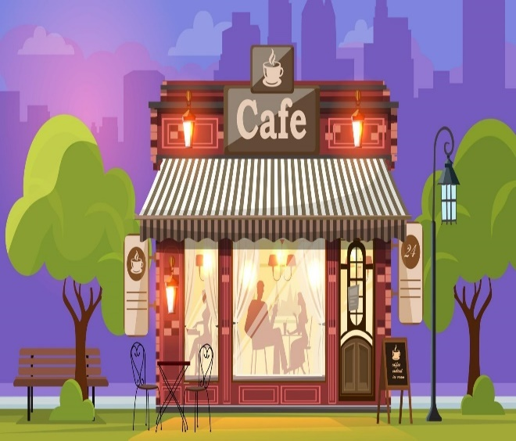**1.Executive Summary:**

**A coffee shop business typically focuses on**

**serving a variety of coffee beverages, teas, and light snacks in a cozy, inviting atmosphere. Key elements include sourcing high-quality coffee beans, creating a unique menu, and providing excellent customer service. The ambiance often encourages social interaction and may feature comfortable seating, Wi-Fi access, and local art. Successful coffee shops also engage with their community through events, loyalty programs, and partnerships with local suppliers. Marketing strategies often leverage social media and word-of-mouth to attract and retain customers. Financially, profitability can be enhanced by managing costs, optimizing menu pricing, and exploring additional revenue streams like merchandise or catering.**

# **2.Products and Services:**

## **2.1. Products:**

### 2.1.1. Coffee Beverages:

* + **Espresso**: Strong, concentrated coffee.
  + **Americano**: Espresso with hot water.
  + **Latte**: Espresso with steamed milk.
  + **Cappuccino**: Equal parts espresso, steamed milk, and foam.
  + **Mocha**: Espresso, chocolate, and steamed milk.
  + **Cold Brew**: Coffee brewed slowly in cold water.
  + **Iced Coffee**: Chilled coffee served over ice.
    1. Specialty Drinks**:**
  + **Pumpkin Spice Latte** (seasonal).
  + **Caramel Macchiato**.
  + **Frappuccino**: Blended iced coffee drink.
  + **Seasonal/limited edition drinks**: Flavors change by season.

### 2.1.3 Non-Coffee Beverages:

* + **Tea**: Black, green, herbal, and iced teas.
  + **Hot Chocolate**: Rich, creamy drink.
  + **Smoothies**: Fruit-based or yogurt smoothies.

### Food Menu:

* + **Pastries**: Muffins, croissants, cookies, and danishes.
  + **Breakfast Items**: Sandwiches, bagels, and toasts.
  + **Salads and Sandwiches**: Light lunch options.

## **Services:**

1. **In-House Café Experience**:
   * Comfortable seating, free Wi-Fi, and a cozy ambiance for customers.
2. **Takeaway/To-Go Orders**:
   * Fast service for customers on the go.
3. **Home Delivery**:
   * Coffee and food delivered via online platforms or apps.
4. **Coffee Subscription Service**:
   * Regular home delivery of coffee beans or pods.
5. **Catering for Events**:
   * Provide coffee, pastries, and food for business meetings, parties, or special occasions.
6. **Workshops and Events**:
   * Host coffee tasting events, barista workshops, or community activities.

## **Hyperlink:**

[**Coffee**](https://en.wikipedia.org/wiki/Coffee)

## 

## **SmartArt**

# **3.Business Plan:**

**Business Concept**

**Market Research**

**Business Structure**

**Operation Plan**

**Marketing Strategy**

**Financial Plan**

**Launch**

# **4.Sales and cost Statistics:**

## **4.1. Table:**

|  |  |  |  |  |  |  |
| --- | --- | --- | --- | --- | --- | --- |
| **Month** | **Sales**  **Revenue**  **($)** | **Cost of Goods**  **Sold (COGS)**  **($)** | **Labor Cost**  **($)** | **Rent and**  **Utilities**  **($)** | **Marketing**  **($)** | **Net Profit**  **($)** |
| **January** | **5000** | **2000** | **1500** | **500** | **300** | **1500** |
| **February** | **6000** | **2500** | **2000** | **700** | **800** | **1900** |
| **March** | **7500** | **3000** | **2200** | **1000** | **850** | **2800** |
| **April** | **8000** | **3200** | **2500** | **2000** | **900** | **3000** |
| **May** | **9500** | **3500** | **3000** | **2500** | **1000** | **4200** |

## **4.2. Chart:**

Top of Form

Bottom of Form